Name: Jarett Waite

City of residence: Santa Clara CIty

Years of residence in current city: 17

Contact email: jwaite@sccity.org

Age: 43

Occupation: Entrepreneur

Web site (if applicable): [www.jarettwaite.com](http://www.jarettwaite.com)

Message (200 Word Maximum):

If you would like to include a picture for your profile, please attach it in this box.

I grew up in a small town in Southern Idaho. I graduated from BYU with a degree in business management. Soon after, I married my wife, Jenna, and we moved back to her hometown of Santa Clara. We're now business owners and the parents of five wonderful children.

I truly feel I have made a positive difference in our community serving on the city council for the last eight years. I have worked hard to research the many issues brought before the council, and strived to reflect the views of citizens. Here are a few of the things I have focused on:

- Served as the Mayor Pro-Tem (vice mayor)

- Spearheaded the effort to bring Utopia Fiber to Santa Clara

- Voted against high density developments in the Valley and the Heights

- Met many residents in their homes to listen to their concerns

- Formed the city’s social media presence

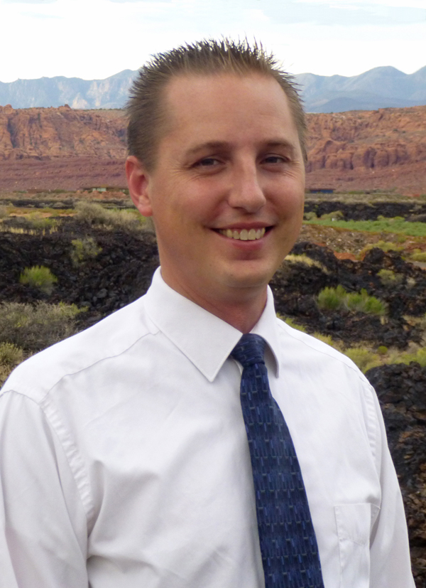

My top concerns include:

- The need for new affordable sources of power to

minimize the impact of the Power Cost Adjustment

- The imbalance of high density and single family homes

in the Heights

- Developing a new source of water within our city

boundaries

- Building a new splash pad and relocating the skate

park